PHC/ COSEDA and CHDs Orientation Workshop Report, 20 September, 2023

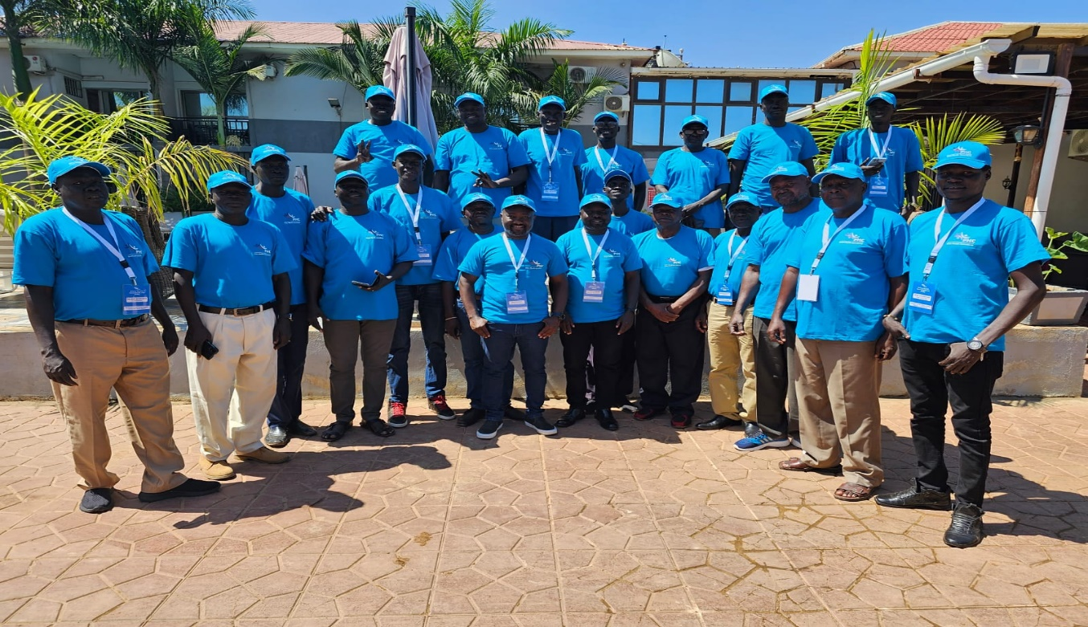
Figure 1 above: It presented CHDs and PHC collaboration during Orientation workshop, Juba (Virgin hotel), 13 Sept 2023.

PHC in collaboration with nine (9) County health departments (CHDs), held a 2 days orientation workshop in Juba, Virgin hotel, from the 12-13 Sept 2023. The main purpose of the workshop was to orient the County health departments (CHDs) personnel, to understand the overall micro plan targets for the 9 counties, discuss strategies to meet the targets and community engagement, besides overall ownership of the vaccination campaign and results by the CHDs.

PHC invited 18 CHDs, consisting of CHD Directors and EPI Supervisors/M&E Officers, from the 9 targeted counties of Abyei, Akobo (East & West), Baliet, Panyikang, Magwi, Maridi, Pigi/Canal, Renk, Yambio. The CHs were fully facilitated by PHC regarding flight bookings, accommodation, daily substance allowance and local transport.

The National Ministry of Health, UNICEF and WHO participated in the 2 days’ workshop. The MOH appreciated PHC for the collaboration with the CHDs and Ministry of Health. UNICEF and WHO provided technical and logistical support in areas of AEFI, RCCE and vaccines/cold chain management.

Methodology
A participatory approach was used during the workshop and mainly group discussions were held between PHC and CHD teams to share experiences, lessons learnt and challenges, relating to the COVID-19 vaccination campaigns (round 1, 2 and 3).

The workshop for day 1, 12 September 2023, focused on sharing PHC performance in R1 and R2 and how similar success can be replicated in R3. The PHC targets for round 3 were discussed with the CHDs including strategies to meet the targets (100% coverage and beyond). The CHDs assured PHC that the targets will be met in Sept R3 campaign. See figure 1 and annex 1 on targets and strategies to meet the targets.
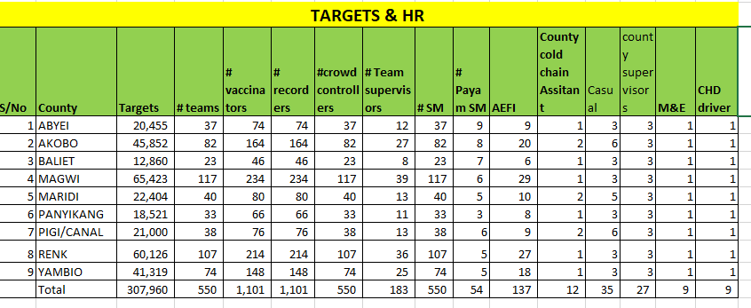
Figure 2: Shows PHC targets for COVID-19 in 9 selected counties

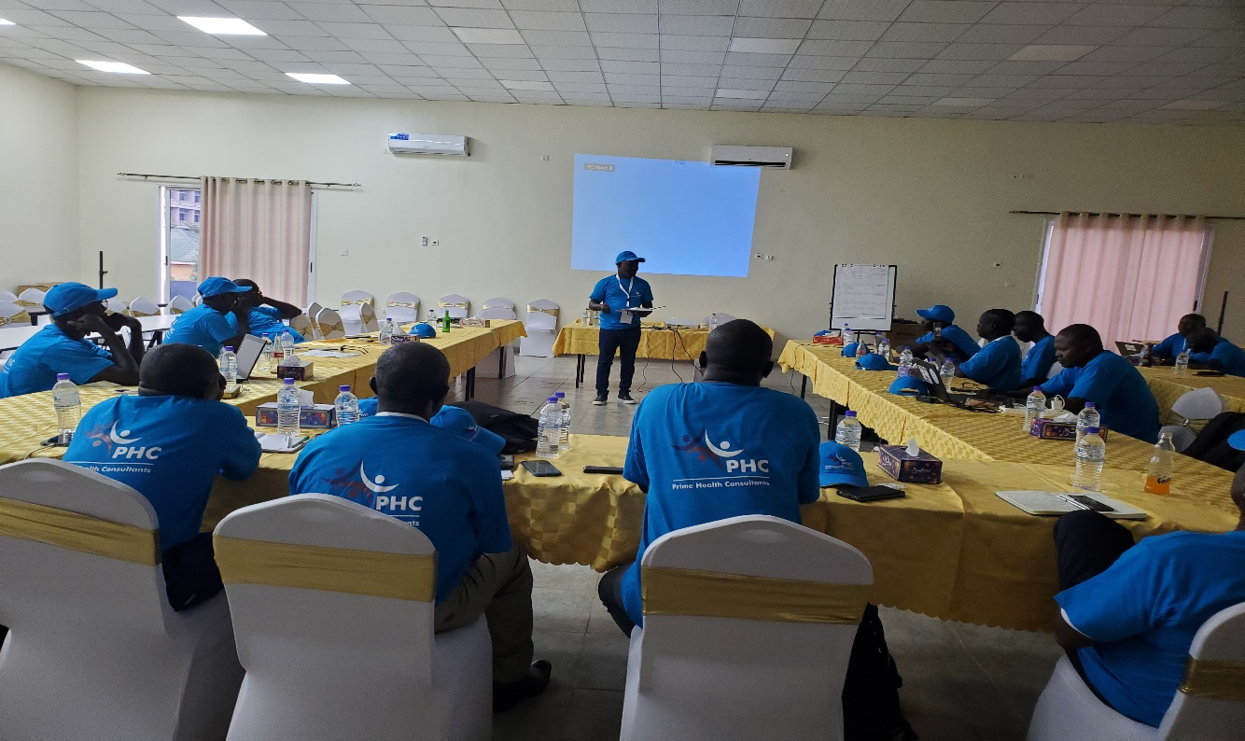
Below photo: Presented PHC and CHD teams discuss targets and strategies for R3 implementation in 9 selected counties, 12 Sept 2023.

In day 2, 13 Sept 2023, Risk Communication and Community Engagement strategies and their implementation during campaign was discussed between PHC SBC Consultant and CHDs from the 9 Counties. The strategies included,
- Advocacy meetings with religious groups, Commissioners, Chiefs, teachers, local leaders, implementing partners, women groups, Youth groups.
- Political leaders to reinforce the vaccination efforts
- Identify influential people as social mobilizers
- House-to-house mobilization: for instant each mobilizer to cover 50 households per day.
- Use of other community networks such as ICMN Mobilizers
- SM activities to start 3 days before the start of campaign
- Identify rumours/cases of refusal and report them
- Mass media (radio, public address system, megaphones, etc)
- IEC materials (posters, banners, flyers, etc)

The strategies discussed to use during campaign implementation included,
- Ready movement plans for the team
- Teams made aware of their daily targets
- Shifting of teams’ location: the team to cover at least 2 villages per day to meet the daily targets
- County leadership ownership of the vaccination campaigns
- Daily reviews meetings to address the challenges identified
- Integration of vaccination with activities such as GFD, OTP days
- Targeting of market days, prisons, schools to conduct vaccination
- Adequate and proper supervision of teams
- Adequate logistical support to the teams

Challenges/Constraints
- Experienced weather and flight logistical challenges to bring all the CHDs from the 9 counties to Juba especially from the hard-to-reach areas such as Akobo.
- Poor communication infrastructure (mobile and internet connectivity) in some of the counties posed communication and coordination challenges.

Annex 1: Strategic approaches for COVID-19 R3 Implementation
1. Abyei
- Means of mobilisation
- CHD have no transportation vehicle.

Strategic Approach & Suggested Solutions
- Early preparation (mobilisations)
- Always get support from ground partners

2. Baliet
- No accessible roads
- Human resource challenge
- Vaccinators incentives
- Network problems
- No main cold chain

Strategic Approach & Suggested Solutions
- Use of boats and canoes
- Budget for other labourers who carry vaccines on their heads to places that boats doesn't reach.
- That boats should be waiting on the other side till the ends of the day and bring back the team with the data (to where the network is available)
- Addition of more active generators.

3. Magwi
- Less population in some areas.
- Inaccessibility to some payams (bad roads)
- Lot of hilly areas in target too
- Cold chain problem

Strategic Approach & Suggested Solutions
- Humans to be carrying vaccines on their shoulders should be deployed
- Addition of two more generators.

4. Maridi
- Rain challenges
- Vaccines movement
- Vaccines carriers
- Incentives complaints by vaccination team

Strategic Approach & Suggested Solutions
- Rainy coats
- Launching campaign by CHD should be early
- Campaign days should be fixed
- Reporting tools should be enough
- Increment of vaccinators incentives
- Additional vaccines carriers

5. Panyikang
- Insecurity in some areas
- Transportation challenges

Strategic Approach & Suggested Solutions
- Canoes needed for transport where boats cannot reach
- Boats
- Supervision

6. Pigi/Canal
- Accessibility challenges
- Unqualified workers
- Network challenges
- Less cold chains
- Incentives

Strategic Approach & Suggested Solutions
- Tree campaign activity
- Use of canoes in some areas
- Deployment of casual workers
- Supervision of M&E
- Needs for more vaccinators

7. Renk
- Availability of islands
- Accessibility challenges
- Less means of mobility
- Incentives

Strategic Approach & Suggested Solutions
- Tractors to be delivering
- Boats and canoes where necessary

8. Yambio
- Mobilisation challenges
- Incentives
- Late supplies of fuel
- Long distance (one village)
- Network

Strategic Approach & Suggested Solutions
- Car hire for Supervision
- Fuel to be supplied in time

Annex 2: Attendance list, 12-13 Sept 2023.
PHC/CHDs Coordinators Contact List, 2023
Sno | State | County | Name | Agency | Title | Contact
1 | Wester Equatoria | Yambio | Juma Richard Gabriel | Prime Health Consultants (PHC) | EPI Officer/ PHC County Coordinator | 0918596178 / 0927500555 (whatsup)  E-mail: Jrichard877@gmail.com
 |  |  | James Ezekiel Ndukpo | Prime Health Consultants (PHC) | CHD Director | 0924932095  E-mail: Jrichard877@gmail.com
2 | Wester Equatoria | Maridi | Joseph Sunday Ernesto | Prime Health Consultants (PHC) | EPI Supervisor/ PHC County Coordinator | 0928409145 (whatsup)  E-mail: Sunday79joseph@gmail.com
 |  |  | Asiki Festo | Prime Health Consultants (PHC) | CHD Director | 0927602403 / 0922580026 (whatsup)  E-mail: asikifesto@gmail.com
3 | Eastern Equatoria | Magwi | Lokoya Tom | Prime Health Consultants (PHC) | EPI Supervisor/ PHC County Coordinator | 0924777531 (whatsup)  E-mail: lokoyatom2020@gmail.com
 |  |  | Martin Okot | Prime Health Consultants (PHC) | CHD Director | 0928135933 (whatsup)  E-mail: okotmartin007@yahoo.co.uk
4 | Jonglei | Akobo | Duoth Pal Deng | Prime Health Consultants (PHC) | Cold Chain Officer/ PHC County Coordinator | 0911112466 (whatsup)  E-mail: duothpal2020@gmail.com
 |  |  | Char Chot Chaar | Prime Health Consultants (PHC) | CHD Director | 0918369082 (whatsup)  E-mail: nhierdhang@gmail.com
5 | Jonglei | Canal/ Pigi | Achuil Matiok | Prime Health Consultants (PHC) | EPI Officer/ PHC County Coordinator | 0925764588 (whatsup)  E-mail: Achuilmatiok68@gmail.com
 |  |  | James Wien Thon | Prime Health Consultants (PHC) | CHD Director | 0921127443/ 0911250433  (whatsup)  E-mail: jameswien2@gmail.com
6 | Warrap | Abyei | Achuil Bol Nyok | Prime Health Consultants (PHC) | EPI Officer/ PHC County Coordinator | 0921847766  E-mail: achuilbol62@gmail.com
 |  |  | Anter John | Prime Health Consultants (PHC) | CHD Director | +211925587654 (whatsup)  anterjohnny@gmail.com
7 | Upper Nile | Baliet | Yai Ayat Monyabur | Prime Health Consultants (PHC) | EPI Officer/ PHC County Coordinator | 0914556471/ 0928782244 (whatsup)  E-mail: akueidengakuei6@gmail.com
 |  |  | Akuei Deng Akuei | Prime Health Consultants (PHC) | CHD Director | 0925532071 / 0912106704  E-mail: akueidengakuei6@gmail.com
8 | Upper Nile | Renk | Thomas Nyer | Prime Health Consultants (PHC) | EPI Officer/ PHC County Coordinator | 0921422100 (whatsup)  E-mail: thomasnyer1@gmail.com
 |  |  | Ayuel Deng Akuei | Prime Health Consultants (PHC) | CHD Director | 0915566609/ 0927333306 (whatsup)  panayuel@gmail.com
9 | Upper Nile | Panyikang | Joseph Oyath Yor | Prime Health Consultants (PHC) | M&E Officer / PHC County Coordinator | 0924768987 / 0929552222 (whatsup)  E-mail: abanojwok78@gmail.com
 |  |  | Aban Ojwok | Prime Health Consultants (PHC) | CHD Director | 0917491944 / 0924672477  E-mail: abanojwok78@gmail.com

